**FIGMA DESIGN – EDUSPHERE FUSION**

**SUBMITTED BY:** VISHAL C VISWAM REG. MCA(2022-2024)B ROLL NO:49

**SCRUM MASTER:**

MS. NAVYAMOL K T ASSISTANT PROFESSOR

DEPARTMENT OF COMPUTER APPLICATIONS

Figma Design Link : [Figma Design (EduSphere Fusion)](https://www.figma.com/file/uuwGWnkkGIRI4sx08XLJoV/EduSphere-Fusion(Mini-Project)?type=design&node-id=0%3A1&mode=design&t=aELoCkOKDzpB5qHT-1)

**Login Page**

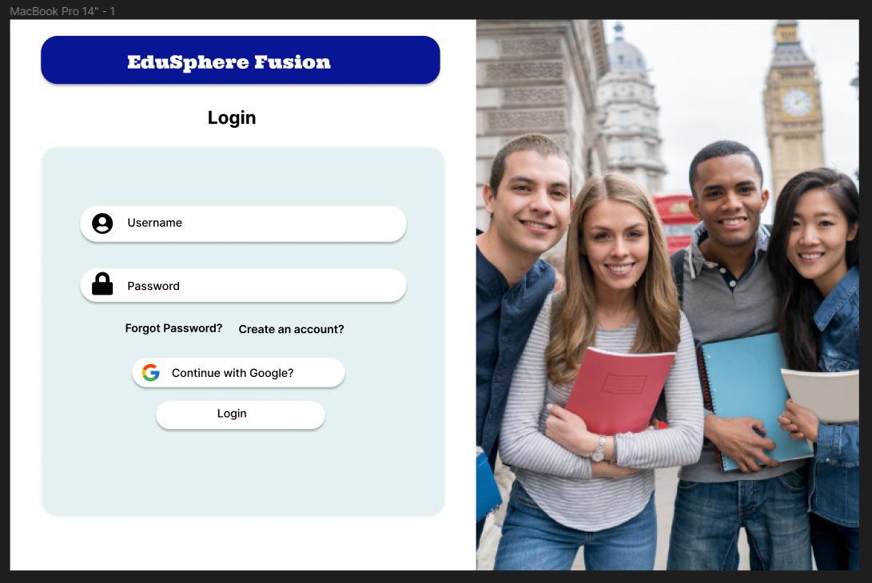

**Registration Page**

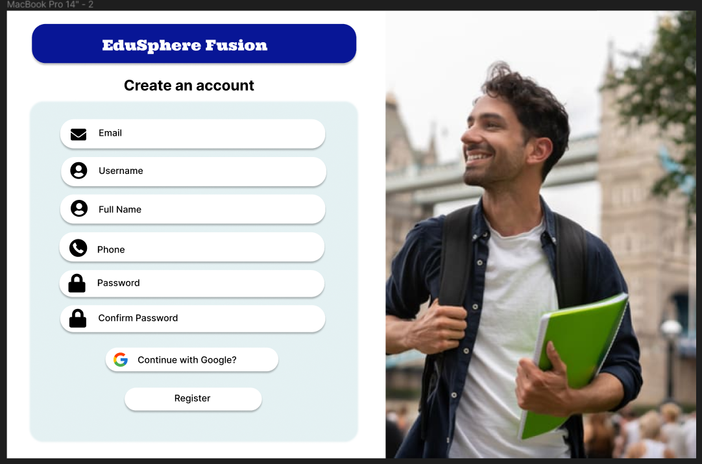

**News Feed**

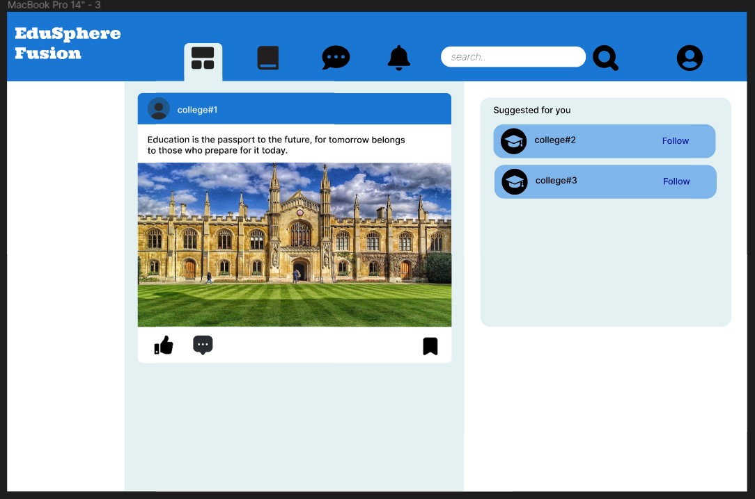

**Profile Page**

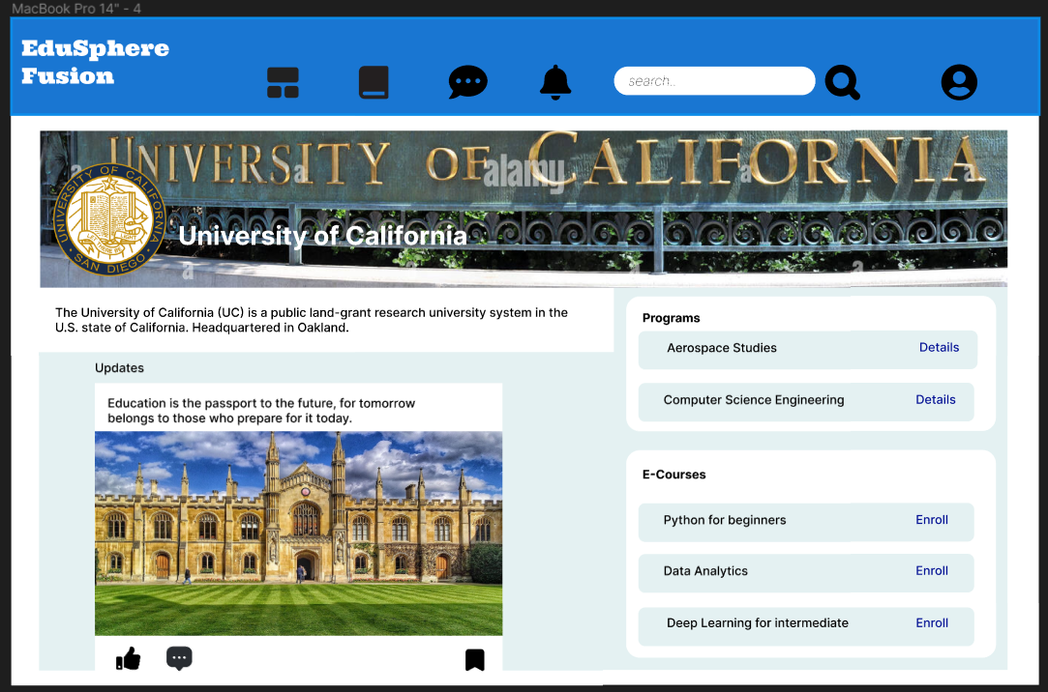

**Course Page**

